New Musical Resources
Patrick Nickelson

Book by Henry Cowell (b. 1897 Menlo Park, California; d. 1965 Shady, New York) written in 1919 but unpublished until 1930. Cowell proposes a “theory of musical relativity” in which pitch, rhythm, and the ‘progress’ of music history are grounded through reference to the structure of the overtone series, the “living essence from which musicality springs.” The text was written when ethnomusicologist Charles Seeger encouraged the young Cowell to rationalize the compositional tools he had been developing.
In the book’s first section, Cowell presents the development of western harmony as progressive upward movement through the overtone series. He suggests the continuation of this same logic into chords based on the ratios beyond the minor seconds he was using to create “cluster” chords. His rhythm chapter proposes the whole-note as the basic unit of time, encouraging division beyond the standard multiples of two into the next numbers in the harmonic series creating third-notes, fifth notes, etc. This method enables the composition of rhythmic patterns that rely on the same ratios as are present between various melodic and harmonic intervals. Many American composers – notably Conlon Nancarrow – have utilized Cowell’s concepts, which predate by several decades the development of similar ideas in integral serialism.

First edition photo:

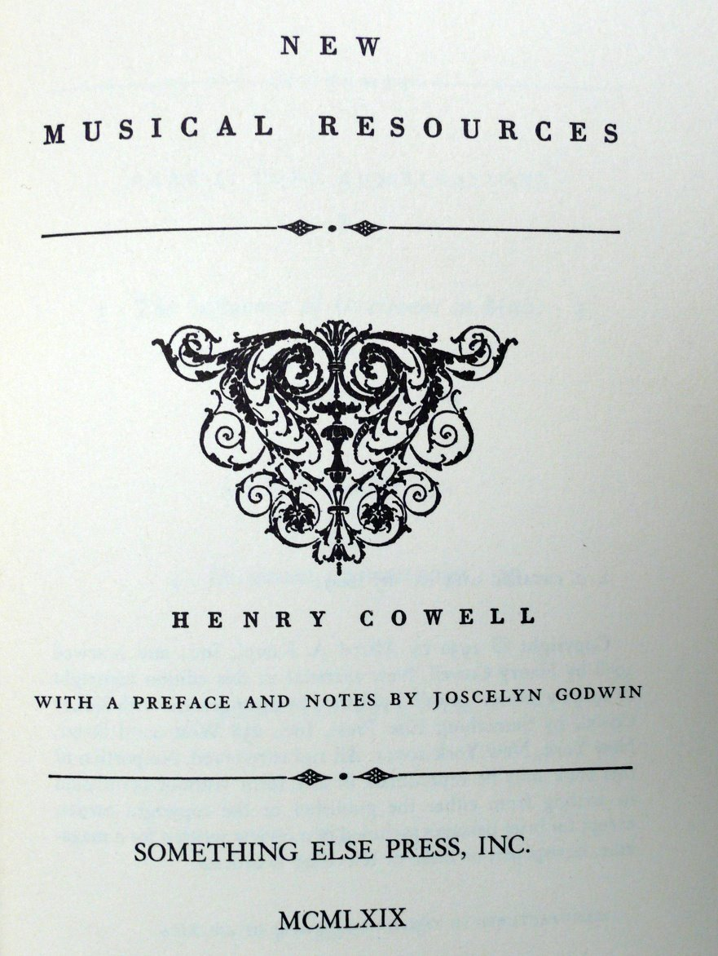

NMR rhythmic notation:

